Sarah Friedman

Influence of environmental stressors and light availability on opsin production in pink scallops (*Chlamys rubida*)

**Abstract**

In a time when ocean acidification is beginning to have large implications for marine organism life, it is important to see how these stressors can alter an animal on a molecular scale. Epigenetic factors are a newly-discovered mechanism in which environmental stressors can influence gene function and expression. By studying epigenetics in scallops under differing light and pH conditions, we hope to visualize how opsin expression changes under stress, which could have negative effects on scallop eyesight. Scallop tissue was sampled from the gill, eye, and mantle for qPCR analysis to quantify opsin expression. Primers failed to amplify after multiple attempts, suggesting some sort of either human error, primer malfunction, or a non-optimized procedure. Future studies should be given a larger amount of time to optimize the qPCR process and encourage results. If opsins are found to degrade under low pH conditions, the implications of ocean acidification could be more dire than originally anticipated.

**Introduction**

Modern day molecular science has been focused on the recent discovery that environmental factors can influence, and even modify how genes function. These epigenetic factors are heritable, allowing organisms and their offspring to more easily adapt to changing or stressful environmental conditions through regulating gene expression. In a time when people are becoming increasingly more aware of the negative effects of global warming and ocean acidification, it is useful to see how chemical alterations of the marine environment affect organisms on a molecular scale and influence gene expression.

Scallops are of particular importance both ecologically as prey items for many marine carnivores and economically through bivalve aquaculture (Shumway et al., 2006). However, given their susceptibility to deterioration from ocean acidification due to their shell composition, they are particularly sensitive to small changes in ocean chemistry (Hofmann et al., 2008). Research on calcifying organisms has reported negative impacts on metamorphosis, growth and survivorship under exposure to small pH decreases (Hofmann et al., 2011; Cooley and Doney, 2009). With the scientific revolution of epigenetics, much research has been conducted on the negative effects of ocean acidification on gene expression and other physiological responses. However, given how important sensory systems are to organism’s survival, relatively little work has been done to quantify the harmful effects of pH changes on sensory processes.

Therefore, in this study we will focus on how environmental changes can influence the production and concentration of opsin in scallop eyes under different environmental conditions. Scallop eyes are restricted to the margins of the mantle and are ideal for experimentation because scallops rely on visual cues more than any other mechanism of predator detection (Shumway et al., 2006). Consequently, negative effects on the visual systems of scallops have the potential to drastically affect their survivability. Previous research has not only focused on the mechanisms of regulation and evolution of phototransduction in bivalves, but the morphology of eyes in scallops as well (Serb et al., 2013; Yarfitz and Hurley, 1994; Speiser and Johnsen, 2008). Research on the correlation between opsins and light availability has been limited to *Limulus*, a genus of horseshoe crab (Battelle et al., 2013). This represents a far more prehistoric perspective into invertebrate vision; here we focus on the more advanced vision of scallops to gain a better understanding of both environmental effects on gene expression and possible sensory degradation as a result of ocean acidification.

**Methods**

Using an otter trawl, 43 specimens of *Chlamys rubida* were collected off the coast of Friday Harbor, San Juan Island. Specimens were maintained in a flow tank for one week before being transferred to the experiment set-up to allow scallops to adjust to the new tanks and conditions. Originally, a preliminary test was conducted with two specimens (one in full light; one in complete darkness) to ensure primers were functional. Before specimens were sampled, they remained in their respective conditions for three days to guarantee they were well adjusted. Tissues were extracted from the adductor muscle, mantle, eyes, and gills and maintained in a -80 C freezer. It should be noted that tissue extractions from the “dark” specimen were done in low-light conditions to avoid inducing opsin production. Eye tissue was difficult to separate from mantle tissue, so both tissues were present in the eye sample. RNA extractions using TriReagent were conducted on the tissues taken from the preliminary experiment before transferring the remainder of the specimens to their respective experimental conditions. These were done according to protocol for the Fish 411 University of Washington course.

For the main experiment, ten scallops were placed in either of four treatment groups with two conditions: light/dark and normal pH (7.8)/ low pH (7.4). Again, these organisms were left to adjust for multiple days. Tissues from the eyes, mantle, and gill were then taken from two specimens in each of the four groups (a total of six specimens) due to time constraints. These samples underwent RNA extraction and were then combined with preliminary samples to form cDNA (all according to class protocol). Initially, a qPCR was performed according to class protocol. PCR was then conducted according to the protocol outlined in a previous paper by Serb et al., where the primers used in this experiment (355F, RhoF2, 1100R) were taken from (Table 1). Both forward primers were attempted to maximize efforts and possible results. The following amounts of reagents were used: 12.5uL green master mix, 1uL primer, 2.5uL MgCl2, 5uL nuclease free water, and 3uL DNA.

**Results**

There was little research on scallops to be found, and even less on opsins and phototransduction in scallops. The primers used are the only ones available for opsins in the *Chlamys* genus, and unfortunately we couldn’t duplicate the experiment outlined by Serb et al. to the point of being able to achieve amplification. It should be noted that after RNA was extracted, every sample was quantified using a NanoDrop; all revealing high concentrations of RNA. The qPCR revealed no results, so we decided to optimize the procedure using PCR, as it is a less expensive method. Again, all primers failed to amplify the correct gene (but the negative was clear, indicating no contamination), evidenced by the gel bands displayed at ~150bp, as opposed to the expected 550bp (Fig. 1).

**Discussion**

While failing to amplify PCR product is a depressing realization for any research team, it is an important step in the optimization process. The primers used were taken from a newer paper, published in 2013, which means that sequencing scallop opsins is still in its infancy and may yet reveal interesting effects of stressors on the sensory systems of scallops. There are a number of reasons why a PCR product could fail to amplify, and given how extensive the PCR process is, there are many steps where human error can nullify the entire process. The protocol used for the RNA extraction is well known to be a less-preferred RNA isolation technique, as it generally introduces genomic contamination to the sample and is expensive (Mannhalter, 2005; Rio et al., 2010). Given that this method was utilized in this experiment, I would recommend future studies utilize another isolation technique. Another possibility is that the paper this experiment was modeled after used DNA extractions, as opposed to RNA for their experiment. Therefore, it is likely that their process was optimized for DNA and would need to again be optimized for an RNA experiment such as this. Furthermore, while duplicating their PCR process was attempted, the gotaq mixture we used was different (containing a premixed ratio of taq, taq buffer, and dNTPs), and preventing an exact replication of the ratio Serb et al. used. It is also possible that, while very few *Chlamys* were tested using these primers in the paper, they are not specifically optimized for this genus (or even the *Chalmys rubida* species).

Human error, while possible, is unlikely due to the fact that multiple samples that were processes by different people were tested and yielded the same result. The most probable reason for amplification failure is a non-optimized procedure for the primers. To remedy this, multiple combinations of PCR reagents and temperatures could be tested in future projects to find the ideal combination for these newly-developed primers. Another possibility is to design completely new primers specific to this species. This would be rather time consuming, but would ensure complete accuracy in future projects on opsins in this species.

This project should be continued in the future under less of a time constraint to accurately reflect variability in opsin gene expression with a larger sample size. If the expected results are found—that opsins are present in mantle and eye tissue and decrease in dark or stressful conditions—then this project has the potential to imply a greater range of effects from ocean acidification than originally anticipated. This result would have implications for scallop, and even general bivalve, survivability under stress and could mean that ocean acidification effect would be even more destructive, not only challenging larval stages, but also adult ones. If it is found that opsin production is influenced very little by stressors and varying light conditions, then this sensory pathway is quite robust, indicatory of its ability to remain active under difficult environmental conditions. If this is the case, it would be interesting to see how much change this system could endure before epigenetic factors are activated. Either way, this project has the potential to expand human knowledge about possible unanticipated effects of ocean acidification and holds merit for remarkable implications with any result.

**Citations**

Battelle, B., Kemple, K.E., Parker, A.K. and Gaddie, C.D. 2013. Opsin1-2,Gqa and arrestin level at *Limulus* rhabdoms are controlled by diurnal light and a circadian clock. The Journal of Experimental Biology. 216:1837-1849.

Cooley, S.R., and Doney, S.C. 2009. Anticipating ocean acidification’s economic consequences on commercial fisheries. Environ. Res. Lett. 4(2): 024007

Hofmann, G.E., Barry, J.P., Edmunds, P.J., Gates, R.D., Hutchins, D.A., Klinger, T., and Sewell, M.A. 2010. The effect of ocean acidification on calcifying organisms in marine ecosystems: An organism-to-ecosystem perspective. Annu Rev Ecol Evol Syst. 41:127-147.

Mannhalter, C., Koizar, D., and Mitterbauer, G. 2005. Evaluation of RNA isolation methods and reference genes for Rt-PCR analysis of rare target RNA. Clin Chem Lab Med. 38(2):171-177.

Serb, J.M., Porath-Krause, A.J., and Pairnett, A.N. 2013. Uncovering a gene duplication of the photoreceptive protein opsin, in scallops (Bivalvia: Pectinidae). Integrative and Comparative Biology. 53(1):68-77.

Shumway, S.E. and Parsons, J.G. 2006. Scallops: Biology, ecology and aquaculture. Elsevier Science; 2 edition.

Speiser, D.I., and Johnsen, S. 2008. Comparative morphology of the concave mirror eyes of scallops (Pectinoidea). Amer. Malac. Bull. 26:27-33.

Yarfitz, S. and Hurley, J.B. 1994. Transduction mechanisms of vertebrate and invertebrate photoreceptors. The Journal of Biological Chemistry. 269:14329:14332.

Hofmann, G.E., O’Donnell, M.J., and Todgham, A.E. 2008. Using functional genomics to explore the effects of ocean acidification on calcifying marine organisms. Marine Ecology Progress Series. 373:219-225.

Rio, D.C., Ares, M., Hannon, G.J., and Nilsen, T.W. 2010. Puification of RNA using TRIzol (TRI reagent). PubMed. Doi: 10.1101.

**Table 1** Opsin primers and sequences used for *Chlamys* molecular work (Serb et al., 2013).



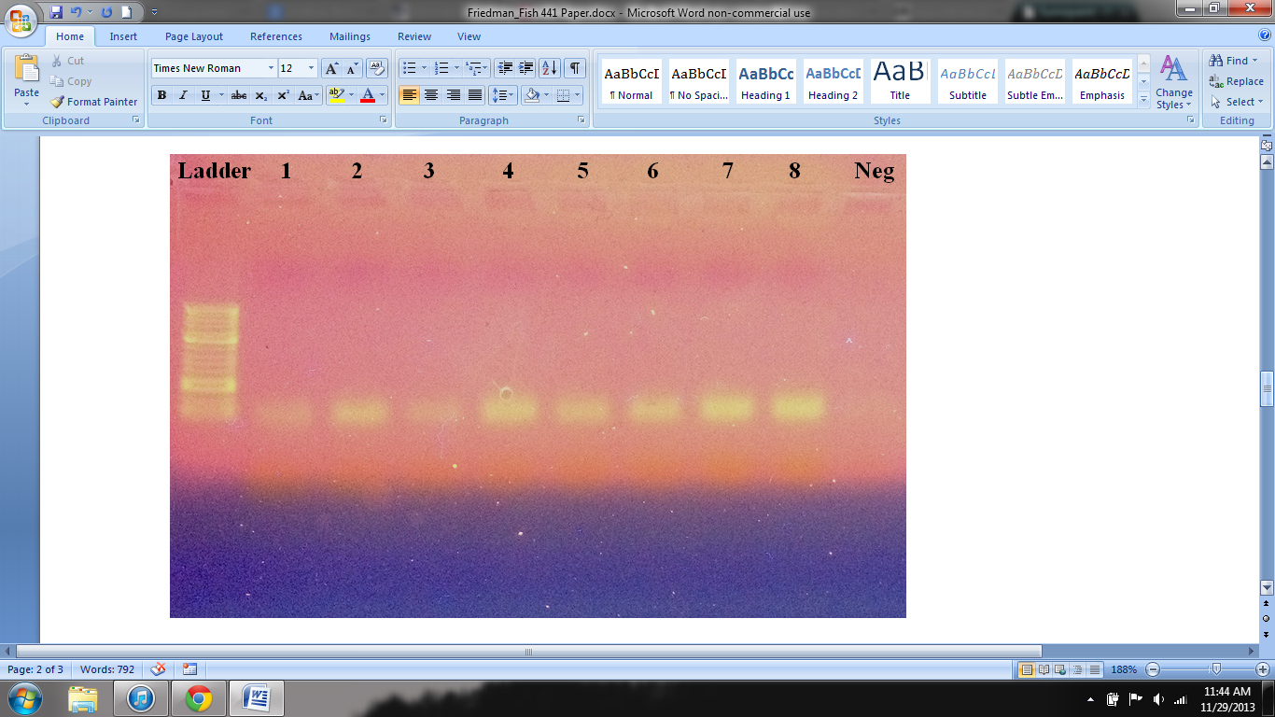

**Fig. 1** Gel image from the second PCR attempt; bands displayed at around 150bp